Neocognitron
Neocognitron is a neural network for visual pattern recognition.neocognitron has an input layer called image receptor and the other layers are simple cell layer , complex cell layer ,hyper complex lower order s-cell layer ,hyper complex higher order c-cell layer and the output layer
- Structure of Neocognitron. 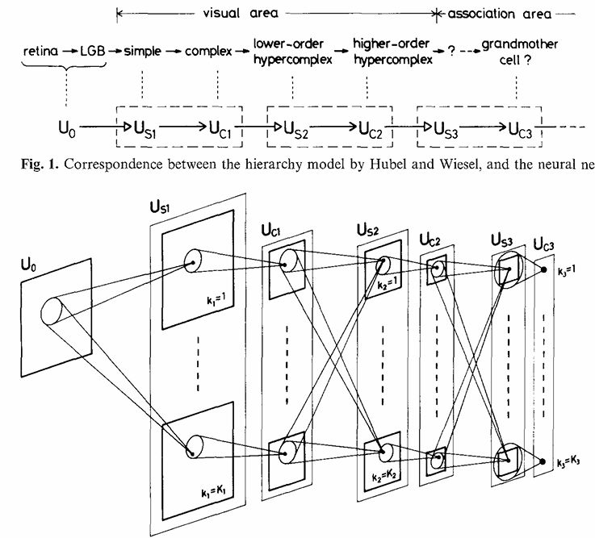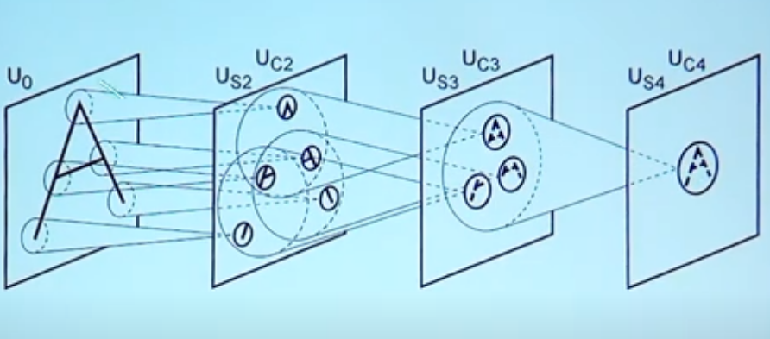This is the structure of the Neocognitron neural network.the network is self - organized by “learning without a teacher” ,and acquires an ability to recognize stimulus.
- Computer Simulation
- The neural network proposed here has been simulated on a digital computer. It can recognize patterns based on geometrical similarity .The pattern recognition is not affected by position shift and shape distortion .In computer simulation there are 7 layer neural network comprising one input layer and 3 modules.Each layer except for the input layer consist of 24 cell planes .the input layer has 16*16 cells.
- 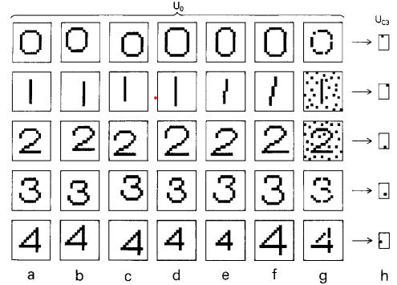

Conclusion
The "Neocognitron" proposed in this paper has an ability to recognize stimulus patterns without affected by shift in position nor by a small distortion in shape of the stimulus patterns. It also has a function of selforganization, which progresses by means of "learning without a teacher".

